[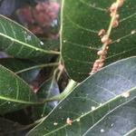](https://mailapi.walla.co.il/sa/i-u8lWkCkUw8Ukg4qqUZTlRtFWt7ImkiOiAiKjVFMzQ2OTRBODRCQSIsICJjIjogImltYWdlL2pwZWciLCAibiI6ICJ5aWZhdDExOSJ9/IMG_4726.JPG)